x

**VmWare Not powering ON because Locked the VMDK File**

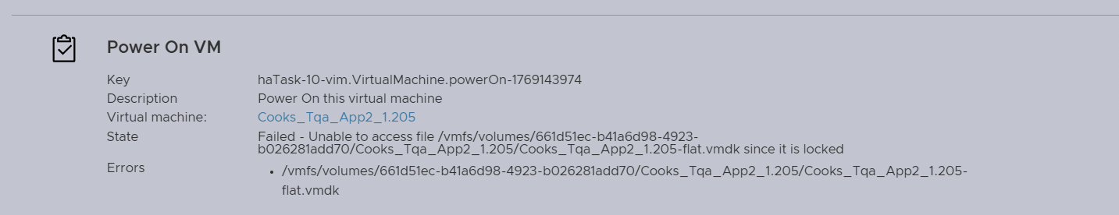

Step 1 :

Login Esxi command line Eg: 10.0.1.200 SSH



Step 2 :

[root@tayana:~] lsof | grep Cooks_Tqa_App2_1.205-flat.vmdk

PID : 4213715 scp FILE 3 /vmfs/volumes/661d51ec-b41a6d98-4923-b026281add70/Cooks_Tqa_App2_1.205/Cooks_Tqa_App2_1.205-flat.vmdk

lsof | grep Cooks_Tqa_App2_1.205-flat.vmdk – VMDK File Name

Step 3 : [root@tayana:~] kill -9 4213715